Our uniform policy  At Shelton we pride ourselves on being smart, well presented and ready for learning. It is our school policy that all children wear school uniform when attending school and we encourage them to take a pride in their personal appearance.  Aims and objectives  Our policy on school uniform is based on the belief that a uniform will;  - promote a sense of pride, community and belonging;  - support the school’s commitment to inclusion;  - be practical, smart, and designed with health and safety in mind; and  - Be good value for money.  Incorrect Uniform  Children who arrive at school not wearing the correct uniform will be loaned an appropriate item to wear for that day if possible.  The same system will apply for children who do not have a PE uniform. Parents will be contacted and asked to obtain the correct uniform or PE kit. |  | School Uniform List;  - Navy blue jumper/cardigan/sweatshirt or hoodie. Optionally with embroidered school logo but this is not required.  - Plain white polo-shirt or button-up shirt  - Dark grey or black shorts, trousers, or skirt  - Blue checked dress (summer term)  - Plain grey, black or white socks  - Plain grey or black tights or leggings.  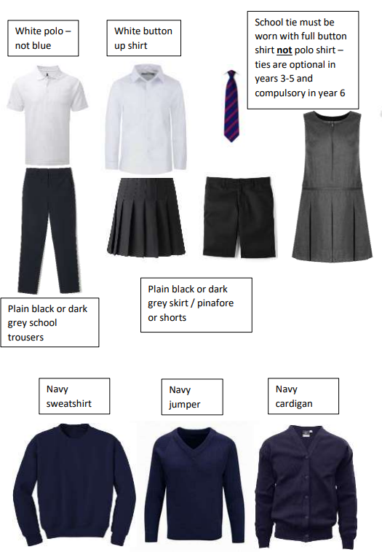  (Some examples of our uniform can be seen on the reverse of this leaflet.)  Please note:  skirts should be an appropriate length and of a style which allows sitting comfortably on the floor  when shorts are worn, they should also be of an appropriate length  ALL items of clothing should be clearly labelled  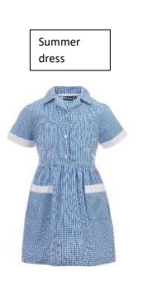 |  | Hair, jewellery and make-up  For many reasons, including safety, we do not allow children to wear jewellery. The exception to this rule is earring studs in pierced ears. Children are required to remove their earrings items during P.E. lessons to prevent them from causing injury. Please note that teachers are not permitted to remove earrings.  Long hair should be tied back with a plain bobble or hairband or in a style so that it is away from children’s faces while working. Bobbles or hairbands should be plain and without large flowers or other decoration attached. Extreme hairstyles are not appropriate for school. The use of styling products should be kept to a minimum and children should not have decorative patterns cut into their hair or have hair coloured or dyed. Make up and nail varnish (including clear, false or acrylics) should not be worn to school.  Children may wear a watch to school providing they do not distract the children from their work. FitBits or Smartwatches are also permitted providing they do not include a camera, microphone or any other recording capability. Any electronic item brought into school that could be used to record will be confiscated and returned at the end of the day. Please note that we do not take any responsibility for the loss or damage of any items brought into school. 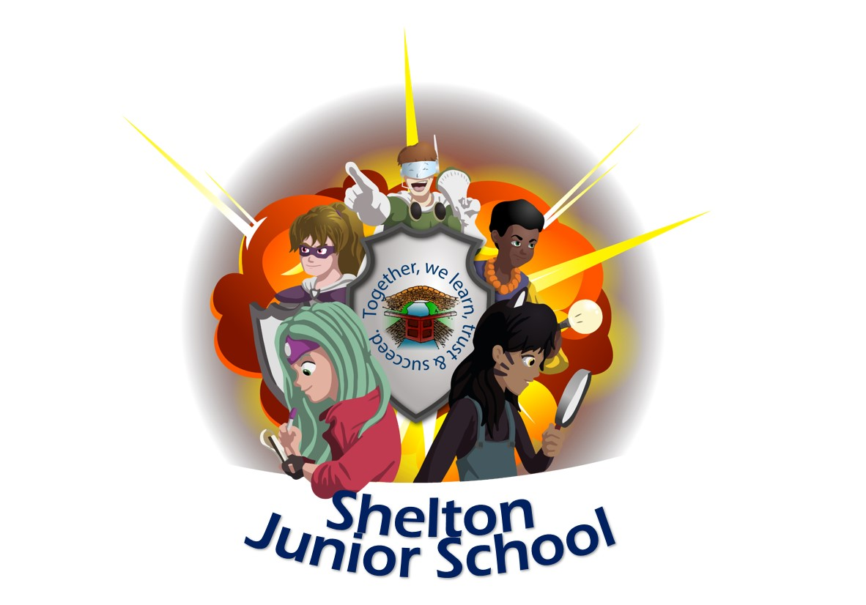
r

P.E. Kit  Children should wear the school PE kit uniform on days when they take part in PE. All items of clothing should be plain, without logos. (Please note that jogging bottoms with Adidas stripes or coloured Nike logos are not permitted). These are available from all supermarkets and online  The PE uniform consists of;  - Plain black or navy shorts  - Plain white t-shirt  - A pair of trainers, these should be suitable for sporting activity. Please avoid branded items but these can be of any colour  - Black or navy tracksuit for outdoor PE in cold weather (plain black or navy jogging bottoms and a plain or navy black hoodie or sweatshirt) Plain black or navy hoodie with or without zip no logos or “Adidas” stripes Plain black or navy joggers or leggings no logos  or “Adidas” stripes.  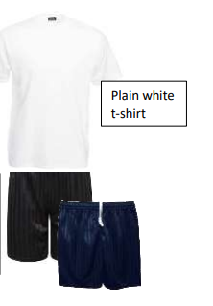  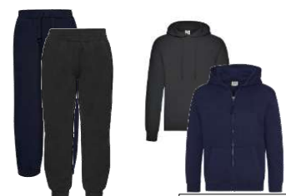  www.sheltonj.derby.sch.uk/parents/school-uniform |  | Shelton Juniors school shoe policy  (PE trainers can be any colour)  Footwear  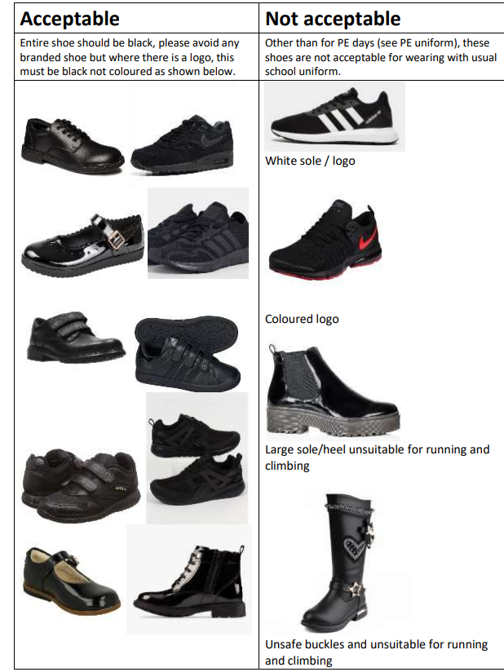  All children are required to wear plain black shoes, ankle boots or black trainers without coloured logos. If wearing trainers, these should not have white soles. (See PE kit for information on PE footwear). Fashion boots are not suitable for school but children may wear sensible ankle boots or similar. For health and safety reasons, we do not allow children to wear shoes with platform soles or heels. See the school shoes guide at the end of this policy for further information. |  | Shelton Junior  School Uniform Policy  

